DUN LAOGHAIRE CHESS CLUB
Presents
A 1-DAY RAPIDPLAY CHESS TOURNAMENT
Open to all on
SUNDAY 14TH AUGUST 2011
START TIME 10.15 AM Sharp
First Prize €300, Second €200 , Third €100 & Grading Prizes €100
(Depending on the number of entries )
Entry fee €25.00. Maximum No. of entries 30, 6 Rounds, 25 minutes each all moves.
Location: Dun Laoghaire Club, 3 Eblana Avenue, Dun Laoghaire.
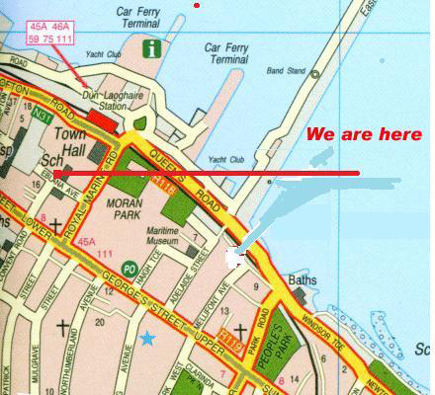
Entry forms, with fees, to :
Richard Daly
64 Cabinteely Green,
Cabinteely
Dublin 18

Phone 087, 9773069 Email Richard50@eircom.net

ENTRY FORM

Name.....................................................................

Address.......................................................................................................................

Contact No:............................

E-mail: ...................................

Club:.......................................

ICU No:...................................

Rating ...................

Note that as the tournament is limited to 30 players maximum, it is advisable to enter early to avoid disappointment. Entries must include fees.

